Electronics Retail Sales Performance Report

G.Yuva dharshini
E25FA051
B.com FinTech with AI

Introduction

This report explains what a sales dashboard built in Power BI shows about a retail business that sells electronics (laptops, phones, TVs and more) through an online store and many physical stores across Indian cities. The aim is to look at how much money the business makes, where it comes from, which products do well, and how sales change over time.

Headline Numbers (KPIs)

KPIs are the big summary figures at the top of the dashboard.

Measure | Value | What it means in plain English
Total Revenue | 5 billion | All the money earned from sales
Total Profit | 980 million | Money left after costs are taken out
Total Orders | 15K (about 15,000) | Number of separate purchases
Total Quantity | 112K (about 112,000) | Number of items sold

- Profit margin: 980M / 5bn is about 19.6%, so the business keeps roughly 20 paise out of every rupee it earns.
- Average revenue per order: 5bn / 15K is about 333,000 per order, which is very high. This suggests large orders or that the 15K figure counts something different from the revenue data (see Section 8).
- Average items per order: 112K / 15K is about 7.5 items.
- Average revenue per item: 5bn / 112K is about 44,600 per item, which fits expensive electronics like laptops and phones.

Revenue by City

The donut chart and bar chart both show revenue split by city.
- The Online store is by far the biggest source: about 3 billion, or 69% of all revenue.
- Physical stores in cities such as Mumbai, New Delhi, Pune, Bengaluru, Noida, Hyderabad, Chandigarh, Gurgaon and Chennai each bring in a small share (individual slices are around 2% to 5%).
- Mumbai, New Delhi and Pune lead among the physical locations, while Chennai and Gurgaon are at the lower end.
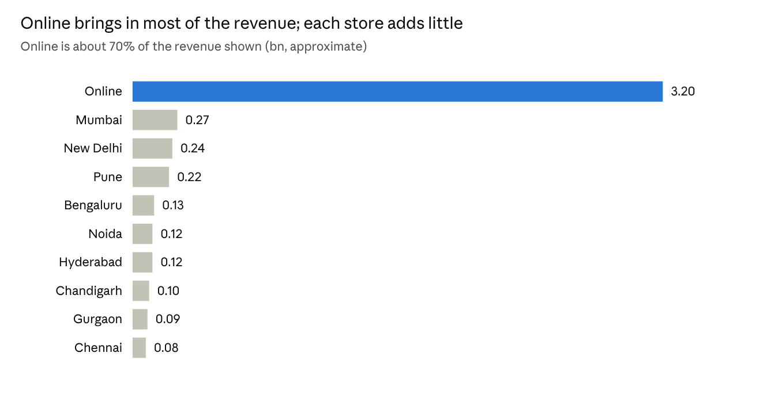
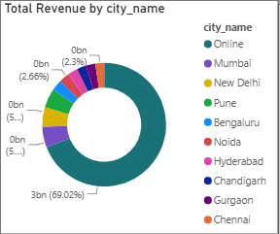

Takeaway: the business depends heavily on online sales. Physical stores contribute, but each one is small by comparison.

Transactions by Store

The bar chart of transactions by store shows the Online Store with more than 10,000 transactions, which is roughly two-thirds of the 15K total orders. Every physical store (for example Mumbai, Hyderabad, Bengaluru, Delhi, Pune, Gurgaon and Chandigarh outlets) has only a few hundred transactions.
Takeaway: online is both the biggest in order count and in revenue, so the two charts agree with each other.

Revenue Over Time

The line chart tracks monthly revenue from 2024 into 2026.
- Monthly revenue sits between about 0.15bn and 0.22bn, with a high near 0.26bn.
- One month drops to about 0.05bn (it appears in early 2026). It may be a partly loaded month, so it should be checked.
- The month axis is sorted by month name (April, August, December...) instead of by date, so the line zigzags and does not show a true trend. Sorting by date in Power BI would fix this.
- Because of this, the report does not claim sales are growing or falling.
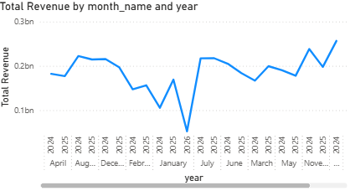

Revenue and Profit by Product Category

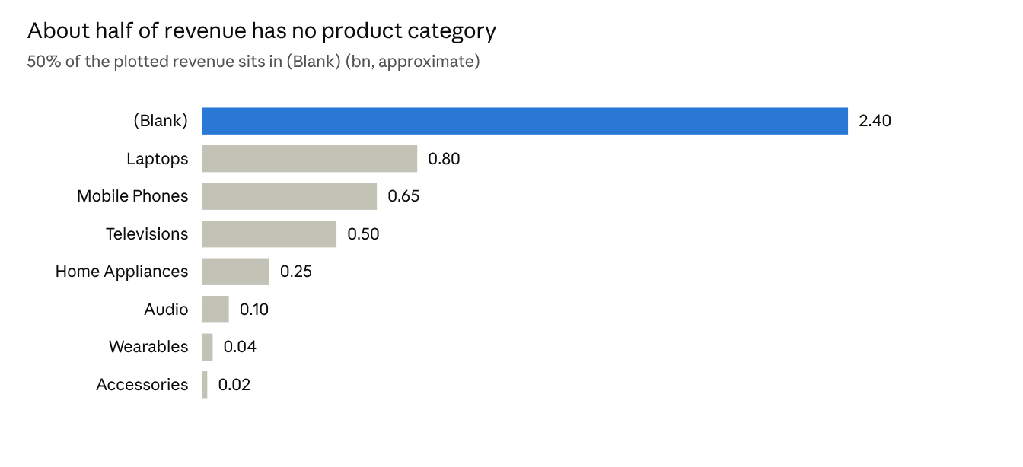
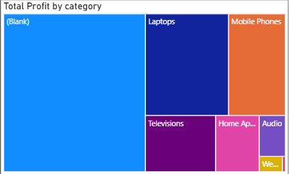

Profit by category: the tree map uses box size to show profit. The (Blank) group is the largest box, followed by Laptops, Mobile Phones, Televisions, Home Appliances and Audio, with Wearables smallest.
Takeaway: among named categories, Laptops and Mobile Phones earn the most. Accessories and Wearables add very little.

Key Findings

- The business earns about 5bn in revenue with a healthy profit margin near 20%.
- About 69% of revenue comes from the online store, so online is the core of the business.
- Laptops, Mobile Phones and Televisions are the best-performing named categories.
- Monthly revenue is fairly stable, with one sharp dip that needs investigation.
- Individual physical stores are small, so there may be room to grow them or rethink their role.

Data Quality Issue

The biggest category in both the revenue chart and the profit treemap is labelled (Blank). That means a large share of sales (roughly half of revenue) has no product category attached. This is likely a data problem, such as products missing from the category table or a broken link between tables in the data model.
This matters because any conclusion about categories is unreliable until it is fixed. Also, the very high average revenue per order (Section 2) suggests the order and revenue figures should be double-checked.

Recommendations

- Fix the blank category: check the relationship between the sales table and the product table, then refresh the dashboard.
- Check the early 2026 dip: confirm whether the data for that month is complete.
- Keep investing in online sales while looking for ways to lift physical store performance.
- Focus on high-value categories such as Laptops and Mobile Phones, and review whether Accessories and Wearables are worth the shelf space.
- Add more detail to the dashboard, such as profit by city, month-on-month growth and filters for year and category.

Conclusion

The dashboard shows a profitable, online-driven electronics retailer with steady monthly sales. The main weaknesses are heavy reliance on one channel and missing category data. Cleaning up the data and growing the physical stores would give a clearer and more balanced picture.

